**1.DATA EXTRACT :-**

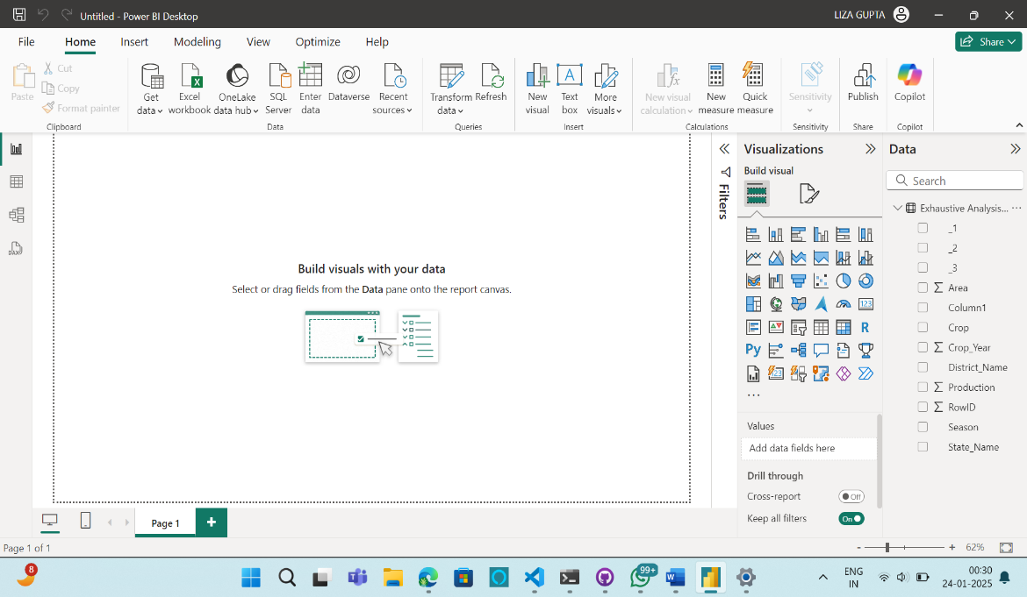

**2.TRANSFORMING THE DATA:-**

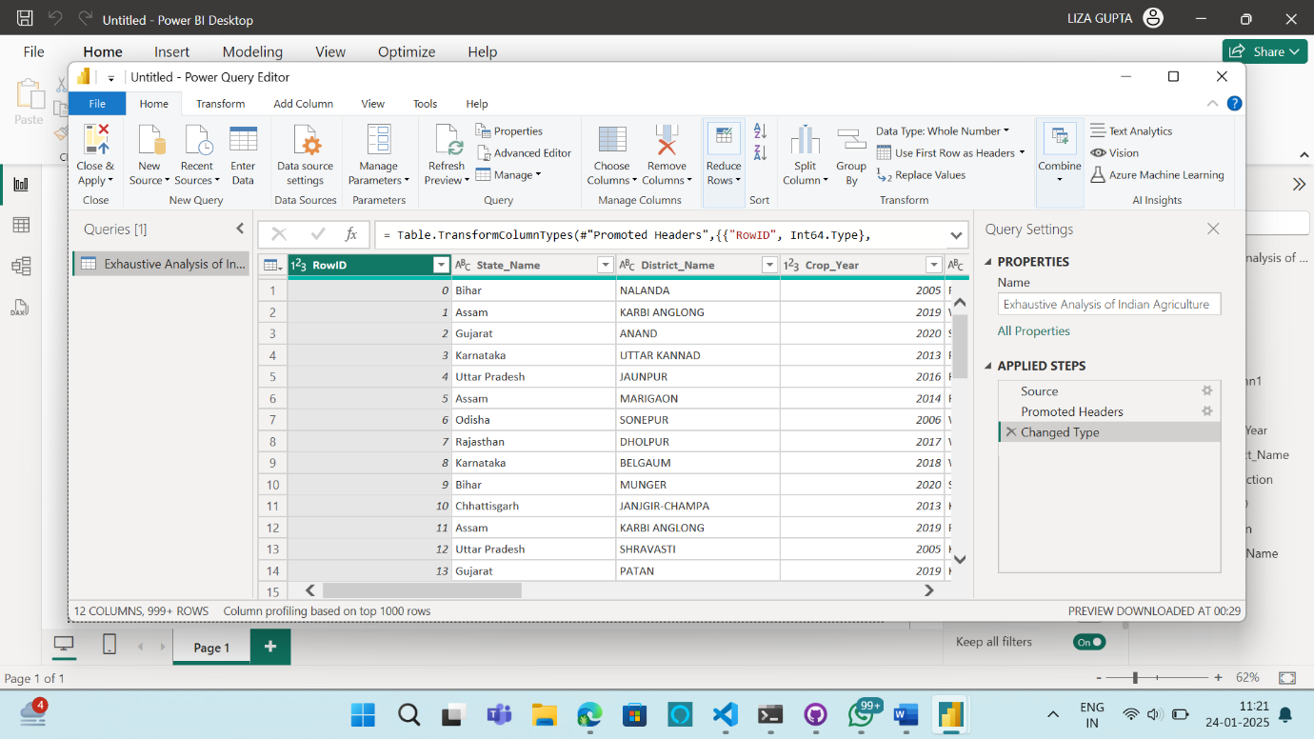

**3.REMOVE THE ROW ID COLUMN:-**

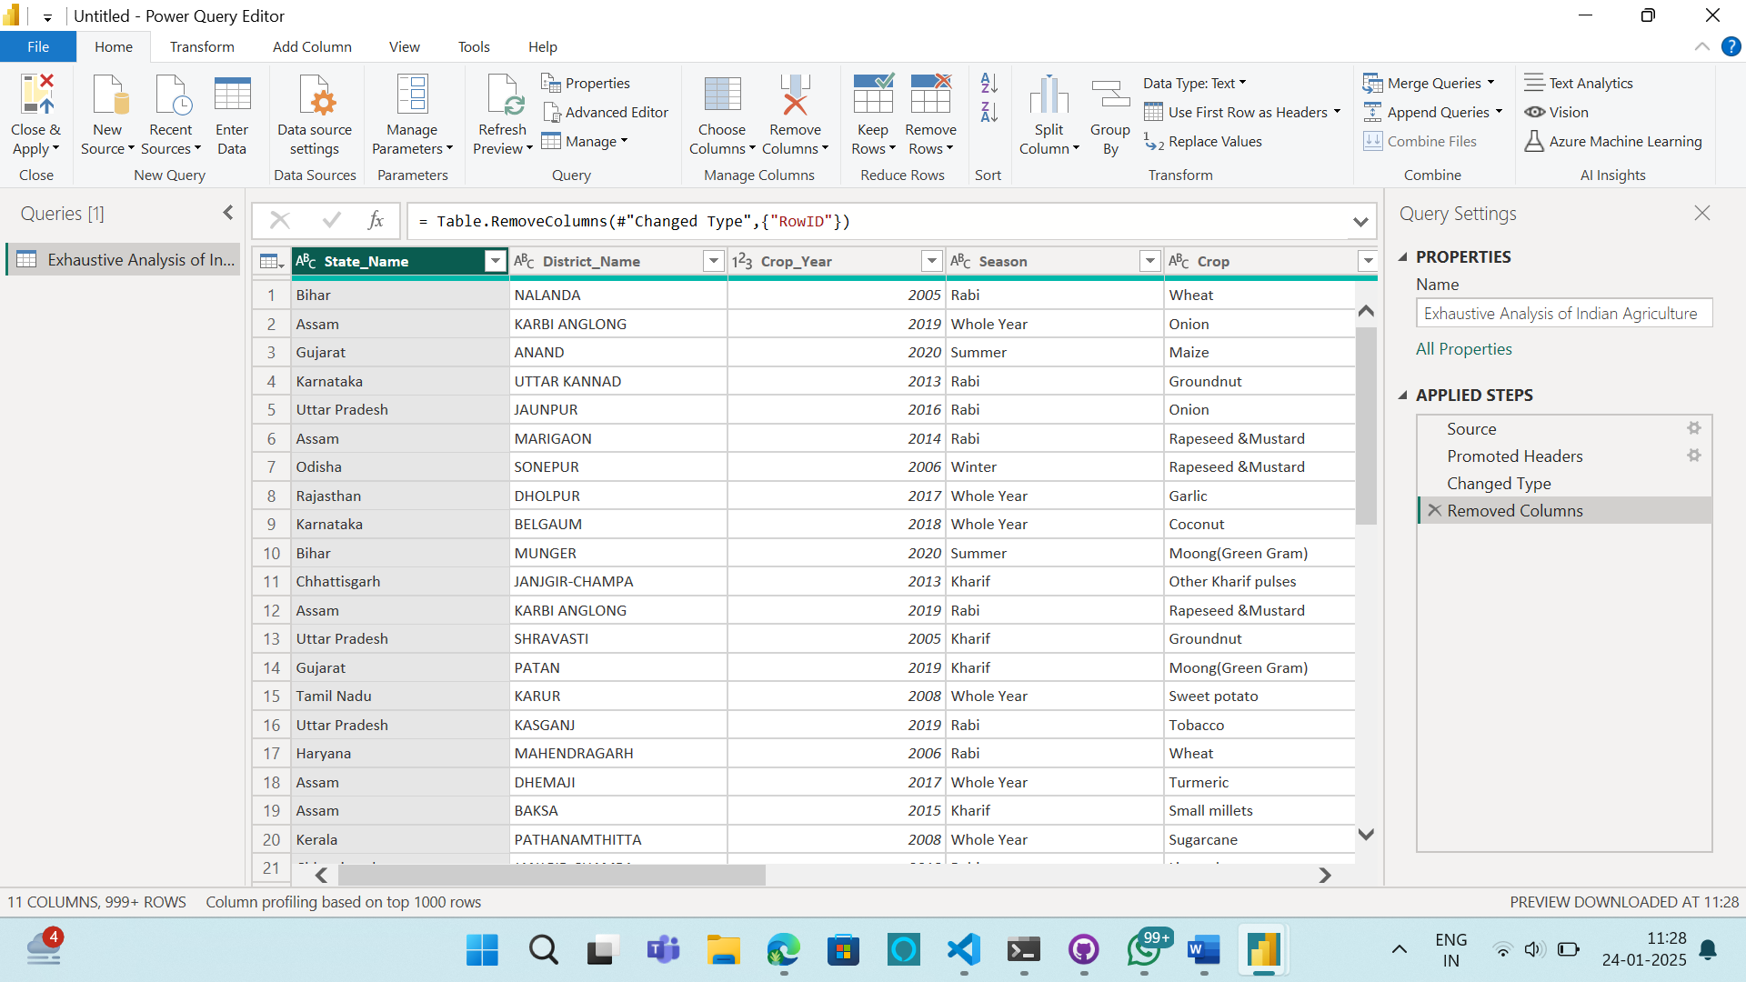

**4.REMOVING ALL THE UNNECESSARY COLUMNS:-**

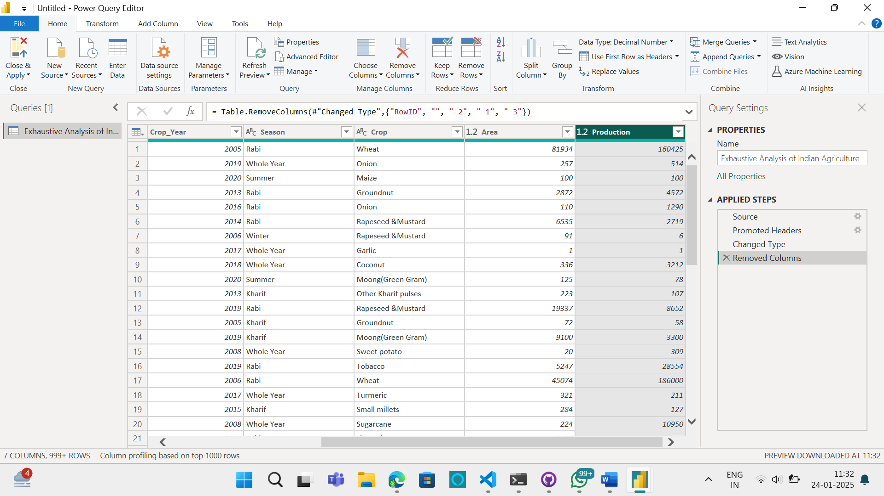

**5. USING CLOSE AND APPLY ALL CHANGES REFLECTED ON THE DESKTOP:-**

